Mars pharmacy DBMS

(The project’s implementation stages)

Group 12.

Team members: - Aliaa Alaa Eldin Farouk

* Shada Gamal Mostafa
* Roaa Ashraf
* Menna Khaled

**Under the supervision of: Dr. Marwa Mansour**

**TABLE OF CONTENTS**

1. **Introduction about the project.**
   1. About the pharmacy DBMS.
   2. How it’ll help in managing the pharmacy.
2. **The ER diagram & relational schema before modification.**
   1. ER diagram
   2. Business rules
   3. Relational schema
3. **Problems that faced us during the implementation & how did we solve them.**
   1. The problems and the solution.
4. **The ER diagram & relational schema after modification.**
   1. ER diagram after modification.
   2. Relational schema after modification.
5. **How can the team improve this project in the future.**
6. **INTRODUCTION ABOUT THE PROJECT.** 
   1. **About the pharmacy DBMS.**

Pharmacy Management system is a database application that will cater the needs of storing, managing, querying and retrieving pharmacy data needs.

* 1. **How it’ll help in managing the pharmacy.**

it helps automate the pharmacy workflow. This includes such tasks as reviewing physician orders and preparing medications, controlling the inventory and making drug orders, handling billing and insurance, providing counseling, identifying incompatibilities, and more — all while following legal protocols and compliances.

**In our project** we managed to make the DBMS control the inventory, making the drug orders either by the pharmacist or the patient online, handling billing and identifying incompatibilities.

1. **THE ER DIAGRAM & RELATIONAL SCHEMA BEFORE. MODIFICATION.**
2. **The ER diagram & relational schema before modification.**

**2.1**. **ER diagram before modification.**

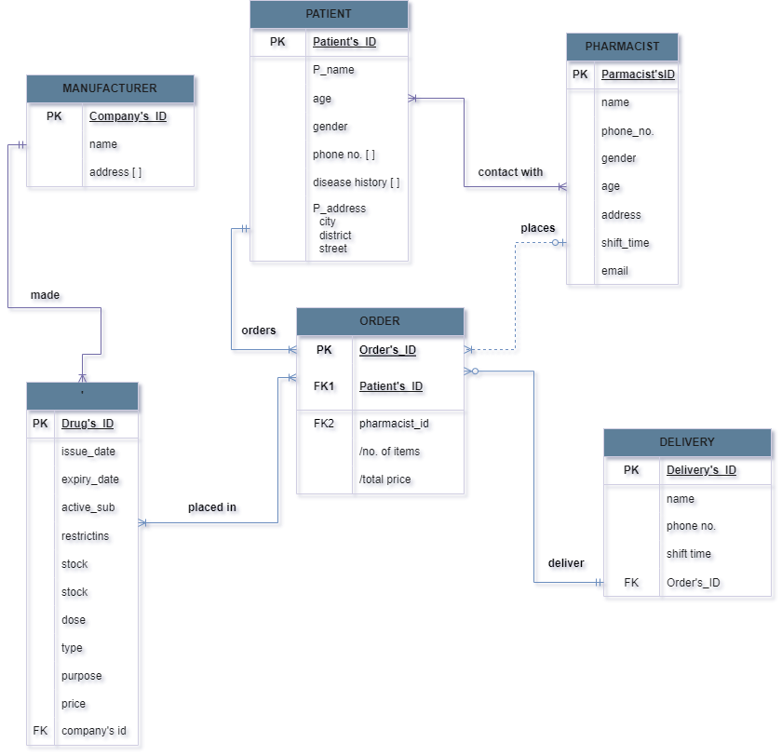

**2.2. Business rules.**

1. Manufacturer must provide one or many drug(s) , one drug is provided by one manufacturer (1:M)

2. Pharmacist may or may not serve one or many patient(s), patient can be served by one or many pharmacist(s) (M:M)

3. a drug may or may not be placed in one or many order(s), order can have one or many drug(s) placed in it (M:M)

4. One delivery can deliver one or many order(s), one order can only be delivered by one delivery (1:M)

5. One patient can order one or many order(s), one order can only be made by one patient (1:M)

6. One pharmacist can place one or many order(s), one order can be placed by one pharmacist (1:M)

**2.3. Relational schema before modification.**

* Patient (**patient_ID,** f_name, l_name, age, gender, phone number, street, district, city, disease history)
* Pharmacist (**pharmacist_ID,** f_name, l_name, age, gender, phone number, address, email, shift_time)
* Order (**order_ID**, no._of_items, total_price, date, patient_ID(fk), pharmacist_ID(fk))
* Manufacturer (**company_ID**, name, address)
* Drug (**drug_ID,** name, issue_date, expiry_date, active_substance, stock, restrictions, dose, type, purpose, price, company_ID(fk))
* Delivery (**delivery_ID,** f_name, l_name, phone number, age, shift_time, order_ID(fk))
* Contact (patient_ID(fk), pharmacist_ID(fk))
* Item (drug_ID(fk), order_ID(fk))

1. **PROBLEMS THAT FACED US DURING THE IMPLEMENTATION & HOW DID WE SOLVE THEM.**

**3.1. The problems and the solutions.**

1. The disease history and phone no. attributes in patient relation is a multivalued attribute which will be hard to input normally.

(We created composite tables for each the patient's disease hisrory and patient's phone no.)

1. Phone no. Attribute in patient relation we wanted to limit the phone number to integer and 11 input numbers only with no letters anomalies we found the numeric() function that only let integers and limit them but it don't accept 0 as the first input.

We made the datatype of the phone number character with 11 input and made a constraint on the input to only be in the [0-9] interval, but it the program couldn’t function with it

( we made the data type char with a limited entries)

1. We wanted to limit the input of gender attribute in patient relation to male and female without taking much effort in writing each time whether the patient was a male or female.

( We created a new data type with using ENUM function that the pharmacist can enter 1 & it will appear as male in the DB or 2 to appear as female or it can be written manually)

1. The time where the order was placed / delivered needed to be added in the order relation.

(We added [delivery_date] attribute)

1. We couldn't use group by function on views to view the drugs placed in one order or view all the disease or phone no.s that one patient have.

(We used order by the patient_id while creating the view of the patientDisease and order by)

1. We wanted the ids for pharmacist and patients and orders and delivery to be serial & increment automatically but from different ranges.

(we used identity function with constraint to start from a certain no.)

1. Each of the patient and pharmacist is a strong entity so the relation between them is weak.

(we modified the relation line connecting them in the ER to dashed line to identify the weak relationship between them)

1. **The ER diagram & relational schema after modification.**

**4.1. ER diagram after modification.**

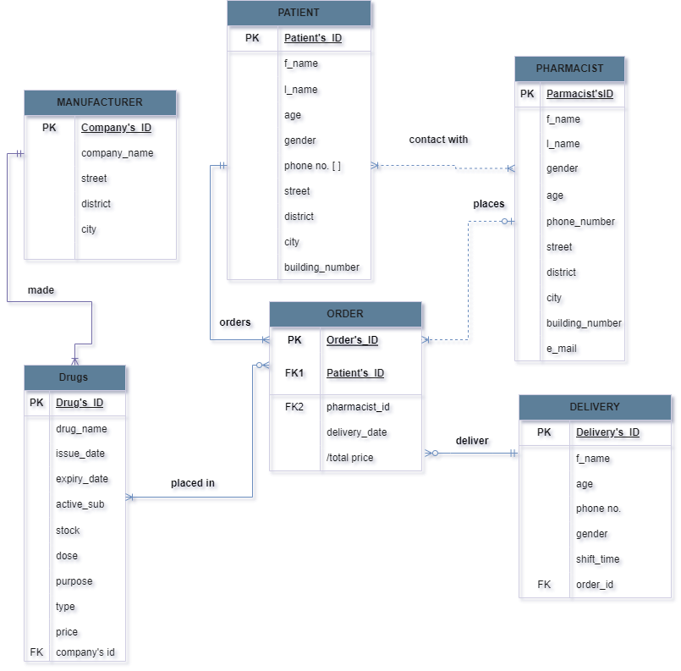

**4.2.** **Relational schema after modification.**

* Patient (**patient_ID,** f_name, l_name, age, gender, phone number, street, district, city, building_number)
* Pharmacist (**pharmacist_ID,** f_name, l_name, age, gender, phone number, street,district,city,building_number, email, shift_time)
* Order (**order_ID**, total_price, delivery_date, patient_ID(fk), pharmacist_ID(fk))
* Manufacturer ( **company_ID**, company_name, street, district ,city)
* Drugs (**drug_ID,** drug_name, issue_date, expiry_date, active_substance, stock, dose, d_type, price, company_ID(fk))
* Delivery (**delivery_ID,** f_name, l_name, phone number, age, shift_time, order_ID(fk))
* Contact (interaction_date ,patient_ID(fk), pharmacist_ID(fk))
* Item (quantity ,drug_ID(fk), order_ID(fk))
* Drug_restrictions(restrictions ,drug_ID(fk))
* Patient_diseases(diseases_history,patient_ID(fk),

phone_no(fk))

* Phone_number(phone_no ,patient_ID(fk))
* Drug_purpose(purpose ,drug_id(fk))

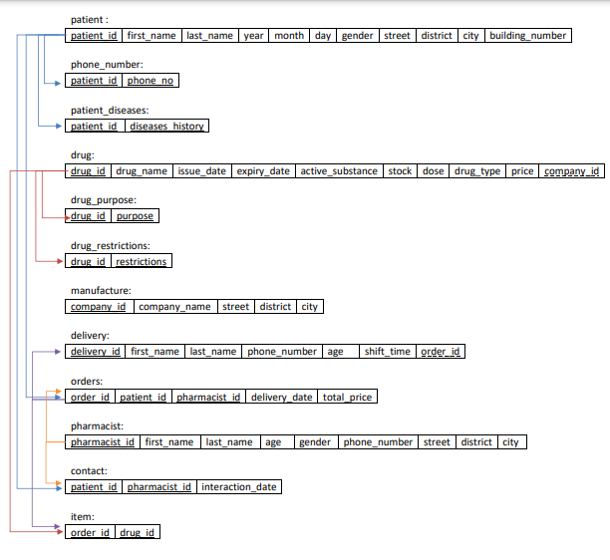

1. **HOW THE TEAM CAN IMPROVE THIS PROJECT IN THE FUTURE.**

We can improve our project by:

- linking between the disease or a symptoms a patient can have with the active substance that can cure it, to make it easier for the pharmacist to search for the effective drugs for each patient.

-linking between the disease a patient can have and the restrictions on each drug, so the drugs that can affect the patient with these won’t appear to the pharmacist.

- interfacing our DBMS to facilitate the data entry for the pharmacist.

- adding an online web page to allow the patients ordering online.